Lesson plan 3: Hyperlinks and navigation

About the lesson
This lesson looks at hyperlinks and how they are used to link the pages of a website together and to link to pages on other websites. Students will also look at how to create and style a navigation bar. They will apply this learning to practical activities using the HTML and CSS files provided.
Learning objectives
By the end of this lesson, students will be able to:
- create a hyperlink to an external web page
- link pages of a website together
- use an image as a clickable hyperlink
- create and style a navigation bar.
National Curriculum
The following subject content from the KS3 National Curriculum is included in this lesson:
- Use two or more programming languages, at least one of which is textual, to solve a variety of computational problems
- Undertake creative projects that involve selecting, using and combining multiple applications, preferably across a range of devices, to achieve challenging goals and meeting the needs of known users
- Create, reuse, revise and repurpose digital artefacts for a given audience, with attention to trustworthiness, design and usability
Links
Websites are integral to modern life and link to every area of the curriculum and beyond.
Key terminology
hyperlink, hyperlink reference, link text, navigation bar
Teaching and learning activities
Share the objectives for the lesson with students (Slide 2 of Lesson 3 presentation).
Starter
Show students an image of a web page including various hyperlinks and ask: What will happen if you click on the hyperlinks on this web page (Slide 3).
Students should identify that a new web page will open, usually replacing the web page currently showing.
Ask: Why are hyperlinks on a website important?
They allow the user to move from page to page within a website or to go to a specific page on another website.

Part 1
Explain the tag and attributes used to create a hyperlink to another page (Slides 4–5 and page 155, plus Video 3.1).
Ask students to complete Activity 3.1: Adding an external hyperlink (Slide 6/page 155/Worksheet 3.1, plus lesson 3_index.html and lesson3_style.css).
- Students are choosing their own search engine so the hyperlink reference will vary. However, the code below indicates what for a link to Google should look like:
<p>Here is a hyperlink to <a href="https://www.google.co.uk">Google</a>.</p>
- When the web page is displayed in a browser, clicking on the hyperlink should open up the search engine's home page.
Explain how the target attribute can be used to open a linked web page in a new browser window (Slide 7 and page 156, plus Video 3.2).
Ask students to complete Activity 3.2: Opening the linked web page in a new window (Slide 8/pages 155–156/Worksheet 3.2, plus lesson 3_index.html and lesson3_style.css).
- The code below shows the previous hyperlink edited to include the target attribute:
- When the web page is displayed in a browser, clicking on the link should open up the search engine's home page in a new browser window.
Part 2
Explain the naming conventions for web pages and creating internal hyperlinks (Slide 9 and page 155, plus Video 3.3).
Ask students to complete Activity 3.3: Adding an internal hyperlink (Slide 10/page 155/Worksheet 3.3, plus lesson 3_index.html, lesson3_style.css and lesson3_page2.html).
- Make sure that students have saved 'lesson3_page2.html' to their 'Designing websites 3' folder.
- Make sure that both files have been saved before 'lesson3_index.html' is opened in a browser and the hyperlinks are tested.
Answers

Explain that replacing the link text with an image makes the image a hyperlink (Slide 11 and page 155, plus Video 3.4).
Ask students to complete Activity 3.4: Using an image as a hyperlink (Slide 12/pages 155–156/Worksheet 3.4, plus lesson 3_index.html, lesson3_style.css, lesson3_page2.html and Hodder-Education-logo.png).
- Make sure that students have saved 'Hodder-Education-logo.png' to their 'Designing websites 3' folder.
- Make sure that 'lesson3_page2.html' has been saved before it is opened in a web browser and the link is tested.
Answers
<p>Click on the image to go to the Hodder Education website.</p>
<a href="https://www.hoddereducation.co.uk" target="_blank"><img src="Hodder-Education-logo.png" alt="Hodder Education logo" width="210" height="140"></a>
Part 3
Explain the role of a navigation bar and how styling basic links can make the website seem much more professional (Slides 13–16 and page 157, plus Video 3.5).
Ask students to complete Activity 3.5: Creating and styling a navigation bar (Slide 17/page 157/Worksheet 3.5, plus lesson3_index.html, lesson3_page2.html and lesson3_style.css).
- Make sure that students have edited 'lesson3_index.html' and 'lesson3_page2.html' to add a navigation bar and hyperlinks.
- Make sure that students have edited the styling in 'lesson3_style.css'. The final results will vary because students are choosing their own colours and font.
- The activity also contains an extension activity, for students to complete if time permits.
Answers
1. and 2.
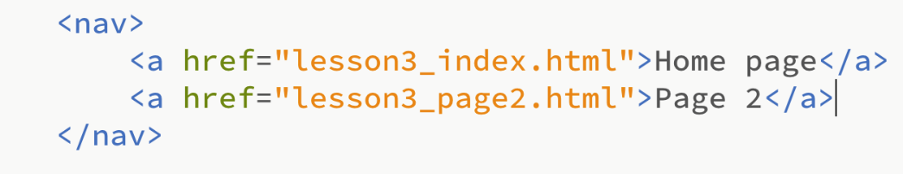
3. Students’ own answers
4.
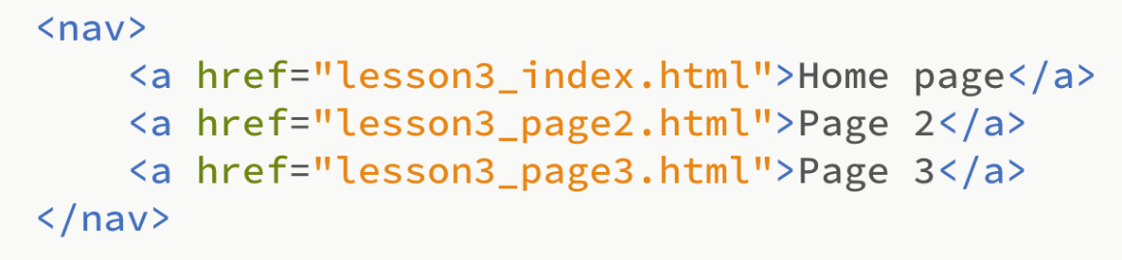
Plenary
Check students' knowledge and understanding with a short question and answer session linked to the learning objectives for the lesson.
- Which tag is used to insert a hyperlink?
(Answer: the anchor tag <a>)
- What does href stand for?
(Answer: hyperlink reference)
- What is the name of the text shown on the screen that the user clicks on to move to a new page?
(Answer: the link text)
- What is a navigation bar?
(Example answer: It is a set of hyperlinks that you click on to move between the pages of a website.)
- What is the effect of adding display: block; to a hyperlink?
(Example answer: It creates a block around the link, with the whole block clickable, not just the text.)
Homework
Ask students to complete any activities they did not finish during the lesson.
Ask students to complete Quiz 3 (Slide 18).
Stretch activities
Students who complete the activities in this lesson quickly could be encouraged to experiment with the styling of their navigation bar by altering the fonts and colours used. They could also investigate the use of the :link and :visited selectors to style links to unvisited and visited pages.
Support activities
Students who struggle in Activities 3.1, 3.2, 3.3 and 3.4 with the correct syntax to use when adding hyperlinks may benefit from being provided with a printout of the skeleton code, with blank spaces to add the specific details for the link being created. These could be completed on paper and checked before being typed into the HTML code. The CSS code for the navigation bar should be typed exactly as per the example given. This code could be provided so that it can simply be copied and pasted into the CSS file.
An additional explanation about navigation bars can be found at https://www.w3schools.com/css/css_navbar_horizontal.asp

